Mobile Application Development
Assignment No. 03

Name: Muhammad Raheel Nawaz
Reg No: 8459
Submitted to: Maam Sadaf Tanvir

Platform No. 01: Fiverr
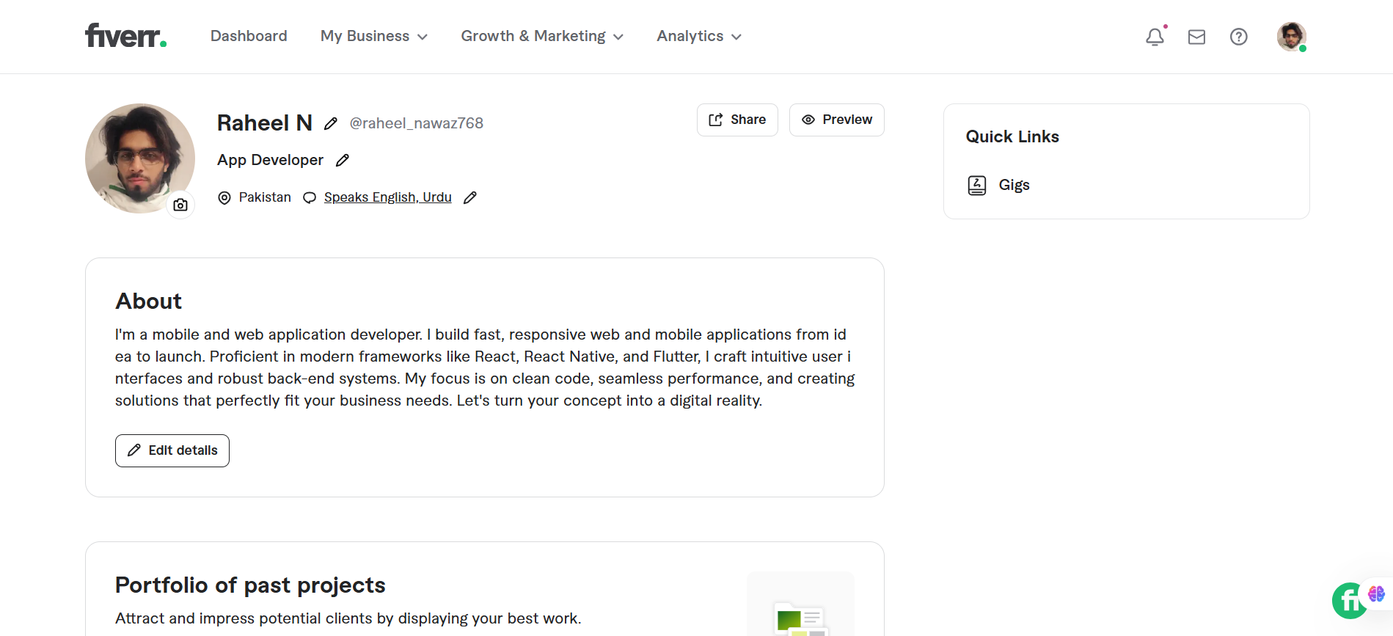

Platform No. 02: Upwork
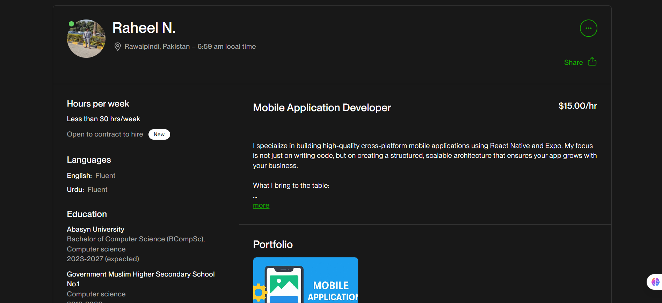

Platform No. 03: Guru
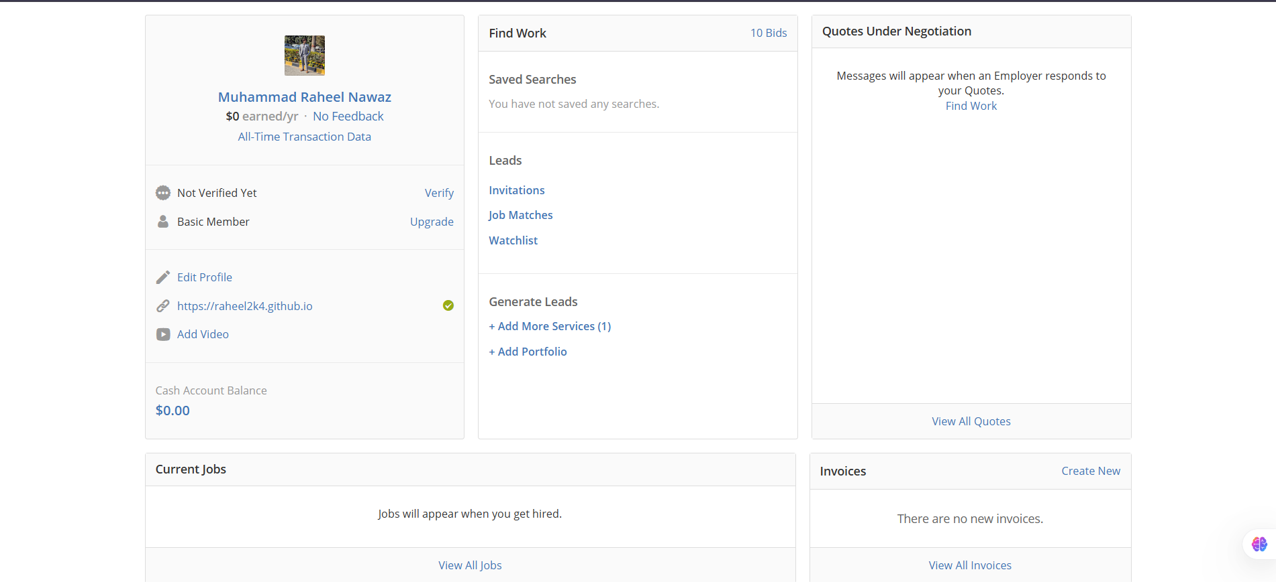

Platform No. 04: Freelancer.com
